

NEO-6

locate, communicate, accelerate

**u-blox 6 GPS Modules**

**Abstract**

Technical data sheet describing the cost effective, high-performance u-blox 6 based NEO-6 series of GPS modules, that brings the high performance of the u-blox 6 positioning engine to the miniature NEO form factor.

These receivers combine a high level of integration capability with flexible connectivity options in a small package. This makes them perfectly suited for mass-market end products with strict size and cost requirements.

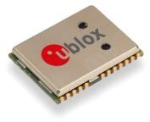

16.0 x 12.2 x 2.4 mm



[**www.u-blox.com**](http://www.u-blox.com/)

|  |  |
| --- | --- |
| **Document Information** | |
| **Title** | NEO-6 |
| **Subtitle** | u-blox 6 GPS Modules |
| **Document type** | Data Sheet |
| **Document number** | GPS.G6-HW-09005-E |
| **Document status** |  |

|  |  |
| --- | --- |
| **Document status information** | |
| Objective Specification | This document contains target values. Revised and supplementary data will be published later. |
| Advance Information | This document contains data based on early testing. Revised and supplementary data will be published later. |
| Preliminary | This document contains data from product verification. Revised and supplementary data may be published later. |
| Released | This document contains the final product specification. |

#### This document applies to the following products:

|  |  |  |  |
| --- | --- | --- | --- |
| **Name** | **Type number** | **ROM/FLASH version** | **PCN reference** |
| NEO-6G | NEO-6G-0-001 | ROM7.03 | UBX-TN-11047-1 |
| NEO-6Q | NEO-6Q-0-001 | ROM7.03 | UBX-TN-11047-1 |
| NEO-6M | NEO-6M-0-001 | ROM7.03 | UBX-TN-11047-1 |
| NEO-6P | NEO-6P-0-000 | ROM6.02 | N/A |
| NEO-6V | NEO-6V-0-000 | ROM7.03 | N/A |
| NEO-6T | NEO-6T-0-000 | ROM7.03 | N/A |

This document and the use of any information contained therein, is subject to the acceptance of the u-blox terms and conditions. They can be downloaded from [www.u-blox.com.](http://www.u-blox.com/)

u-blox makes no warranties based on the accuracy or completeness of the contents of this document and reserves the right to make changes to specifications and product descriptions at any time without notice. Reproduction, use or disclosure to third parties without express permission is strictly prohibited. Copyright © 2011, u-blox AG.

u-blox® is a registered trademark of u-blox Holding AG in the EU and other countries. ARM® is the registered trademark of ARM Limited in the EU and other countries.

# Contents

[Contents 3](#_bookmark0)

1. [Functional description 5](#_bookmark1)
   1. [Overview 5](#_bookmark2)
   2. [Product features 5](#_bookmark3)
   3. [GPS performance 6](#_bookmark4)
   4. [Block diagram 7](#_bookmark11)
   5. [Assisted GPS (A-GPS) 7](#_bookmark12)
   6. [AssistNow Autonomous 7](#_bookmark13)
   7. [Precision Timing 8](#_bookmark14)
      1. [Time mode 8](#_bookmark15)
      2. [Timepulse and frequency reference 8](#_bookmark17)
      3. [Time mark 8](#_bookmark18)
   8. [Raw data 8](#_bookmark19)
   9. [Automotive Dead Reckoning 8](#_bookmark20)
   10. [Precise Point Positioning 9](#_bookmark21)
   11. [Oscillators 9](#_bookmark22)
   12. [Protocols and interfaces 9](#_bookmark23)
       1. [UART 9](#_bookmark24)
       2. [USB 9](#_bookmark25)
       3. [Serial Peripheral Interface (SPI) 9](#_bookmark26)
       4. [Display Data Channel (DDC) 10](#_bookmark27)
   13. [Antenna 10](#_bookmark28)
   14. [Power Management 10](#_bookmark29)
       1. [Maximum Performance Mode 10](#_bookmark30)
       2. [Eco Mode 10](#_bookmark31)
       3. [Power Save Mode 11](#_bookmark32)
   15. [Configuration 11](#_bookmark33)
       1. [Boot-time configuration 11](#_bookmark34)
   16. [Design-in 11](#_bookmark37)
2. [Pin Definition 12](#_bookmark38)
   1. [Pin assignment 12](#_bookmark39)
3. [Electrical specifications 14](#_bookmark40)
   1. [Absolute maximum ratings 14](#_bookmark41)
   2. [Operating conditions 15](#_bookmark43)
   3. [Indicative power requirements 15](#_bookmark44)
   4. [SPI timing diagrams 16](#_bookmark49)
      1. [Timing recommendations 16](#_bookmark50)
4. [Mechanical specifications 17](#_bookmark51)
5. [Qualification and certification 18](#_bookmark52)
   1. [Reliability tests 18](#_bookmark53)
   2. [Approvals 18](#_bookmark54)
6. [Product handling & soldering 19](#_bookmark55)
   1. [Packaging 19](#_bookmark56)
      1. [Reels 19](#_bookmark57)

[6.1.1 Tapes 20](#_bookmark58)

* 1. [Moisture Sensitivity Levels 21](#_bookmark61)
  2. [Reflow soldering 21](#_bookmark62)
  3. [ESD handling precautions 21](#_bookmark63)

1. [Default settings 22](#_bookmark64)
2. [Labeling and ordering information 23](#_bookmark65)
   1. [Product labeling 23](#_bookmark66)
   2. [Explanation of codes 23](#_bookmark68)
   3. [Ordering information 24](#_bookmark71)

[Related documents 24](#_bookmark72)

[Revision history 24](#_bookmark77)

[Contact 25](#_bookmark78)

# Functional description

## Overview

The NEO-6 module series is a family of stand-alone GPS receivers featuring the high performance u-blox 6 positioning engine. These flexible and cost effective receivers offer numerous connectivity options in a miniature 16 x 12.2 x 2.4 mm package. Their compact architecture and power and memory options make NEO-6 modules ideal for battery operated mobile devices with very strict cost and space constraints.

The 50-channel u-blox 6 positioning engine boasts a Time-To-First-Fix (TTFF) of under 1 second. The dedicated acquisition engine, with 2 million correlators, is capable of massive parallel time/frequency space searches, enabling it to find satellites instantly. Innovative design and technology suppresses jamming sources and mitigates multipath effects, giving NEO-6 GPS receivers excellent navigation performance even in the most challenging environments.

## Product features

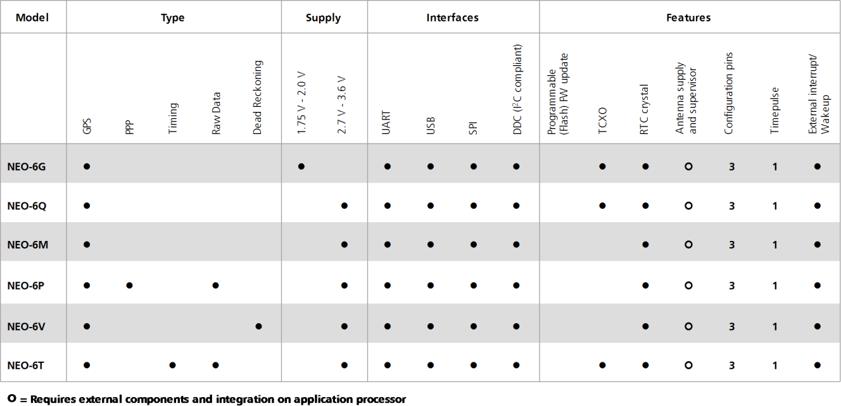

**Table 1: Features of the NEO-6 Series**

pointingfinger_bAll NEO-6 modules are based on GPS chips qualified according to AEC-Q100. See Chapter [5.1](#_bookmark53) for further information.

## GPS performance

|  |  |  |  |  |
| --- | --- | --- | --- | --- |
| **Parameter** | **Specification** |  |  |  |
| Receiver type | 50 Channels  GPS L1 frequency, C/A Code SBAS: WAAS, EGNOS, MSAS |  |  |  |
| Time-To-First-Fix1 |  | NEO-6G/Q/T | NEO-6M/V | NEO-6P |
|  | Cold Start2 | 26 s | 27 s | 32 s |
|  | Warm Star[t2](#_bookmark5) | 26 s | 27 s | 32 s |
|  | Hot Star[t2](#_bookmark5) | 1 s | 1 s | 1 s |
|  | Aided Starts3 | 1 s | <3 s | <3 s |
| Sensitivity4 |  | NEO-6G/Q/T | NEO-6M/V | NEO-6P |
|  | Tracking & Navigation | -162 dBm | -161 dBm | -160 dBm |
|  | Reacquisition5 | -160 dBm | -160 dBm | -160 dBm |
|  | Cold Start (without aiding) | -148 dBm | -147 dBm | -146 dBm |
|  | Hot Start | -157 dBm | -156 dBm | -155 dBm |
| Maximum Navigation update rate |  | NEO-6G/Q/M/T | NEO-6P/V |  |
|  |  | 5Hz | 1 Hz |  |
| Horizontal position accuracy6 | GPS | 2.5 m |  |  |
|  | SBAS | 2.0 m |  |  |
|  | SBAS + PPP7 | < 1 m (2D, R50)8) |  |  |
|  | SBAS + PPP[7](#_bookmark7) | < 2 m (3D, R50[)8](#_bookmark8) |  |  |
| Configurable Timepulse frequency range |  | NEO-6G/Q/M/P/V | NEO-6T |  |
|  |  | 0.25 Hz to 1 kHz | 0.25 Hz to 10 MHz | |
| Accuracy for Timepulse signal | RMS | 30 ns |  | |
|  | 99% | <60 ns |  | |
|  | Granularity | 21 ns |  | |
|  | Compensated9 | 15 ns |  | |
| Velocity accuracy[6](#_bookmark6) |  | 0.1m/s |  | |
| Heading accuracy[6](#_bookmark6) |  | 0.5 degrees |  | |
| Operational Limits | Dynamics | 4 g |  | |
|  | Altitude10 | 50,000 m |  | |
|  | Velocity[10](#_bookmark9) | 500 m/s |  | |

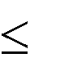**Table 2: NEO-6 GPS performance**

1 All satellites at -130 dBm

2 Without aiding

3 Dependent on aiding data connection speed and latency

4 Demonstrated with a good active antenna

5 For an outage duration 10s

6 CEP, 50%, 24 hours static, -130dBm, SEP: <3.5m

7 NEO-6P only

8 Demonstrated under following conditions: 24 hours, stationary, first 600 seconds of data discarded. HDOP < 1.5 during measurement period, strong signals. Continuous availability of valid SBAS correction data during full test period.

9 Quantization error information can be used with NEO-6T to compensate the granularity related error of the timepulse signal

10 Assuming Airborne <4g platform

## Block diagram

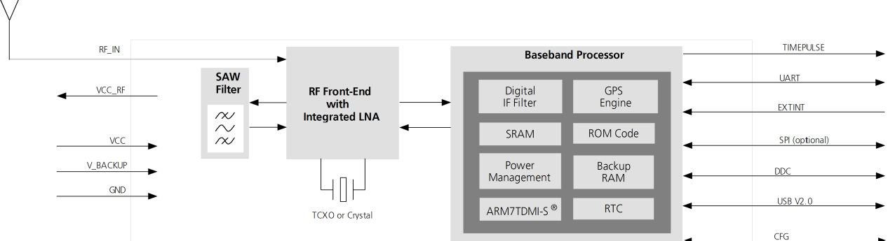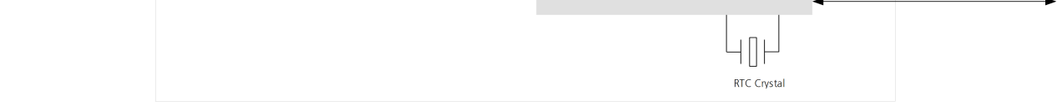

**Figure 1: Block diagram (For available options refer to the product features table in section** [**1.2)**](#_bookmark3)**.**

## Assisted GPS (A-GPS)

Supply of aiding information like ephemeris, almanac, rough last position and time and satellite status and an optional time synchronization signal will reduce time to first fix significantly and improve the acquisition sensitivity. All NEO-6 modules support the u-blox AssistNow Online and AssistNow Offline A-GPS services11 and are OMA SUPL compliant.

## AssistNow Autonomous

AssistNow Autonomous provides functionality similar to Assisted-GPS without the need for a host or external network connection. Based on previously broadcast satellite ephemeris data downloaded to and stored by the GPS receiver, AssistNow Autonomous automatically generates accurate satellite orbital data (“AssistNow Autonomous data”) that is usable for future GPS position fixes. AssistNow Autonomous data is reliable for up to 3 days after initial capture.

u-blox’ AssistNow Autonomous benefits are: Faster position fix



No connectivity required

Complementary with AssistNow Online and Offline services No integration effort, calculations are done in the background

pointingfinger_bFor more details see the u-blox 6 Receiver Description including Protocol Specification [2].

11 AssistNow Offline requires external memory.

## Precision Timing

### Time mode

NEO-6T provides a special Time Mode to provide higher timing accuracy. The NEO-6T is designed for use with stationary antenna setups. The Time Mode features three different settings described in [Table 3:](#_bookmark16) Disabled, Survey-In and Fixed Mode. For optimal performance entering the position of the antenna (when known) is recommended as potential source of errors will be reduced.

|  |  |
| --- | --- |
| **Time Mode Settings** | **Description** |
| **Disabled** | Standard PVT operation |
| **Survey-In** | The GPS receiver computes the average position over an extended time period until a predefined maximum standard deviation has been reached. Afterwards the receiver will be automatically set to  Fixed Mode and the timing features will be activated. |
| **Fixed Mode** | In this mode, a fixed 3D position and known standard deviation is assumed and the timing features are activated. Fixed Mode can either be activated directly by feeding pre-defined position coordinates (ECEF  - Earth Center Earth Fixed format) or by performing a Survey-In.  In Fixed mode, the timing errors in the TIMEPULSE signal which otherwise result from positioning errors are eliminated. Single-satellite operation is supported. For details, please refer to the *u-blox 6 Receiver*  *Description including Protocol Specification* [[2].](#_bookmark74) |

**Table 3: Time mode settings**

### Timepulse and frequency reference

NEO-6T comes with a timepulse output which can be configured from 0.25 Hz up to 10 MHz. The timepulse can either be used for time synchronization (i.e. 1 pulse per second) or as a reference frequency in the MHz range. A timepulse in the MHz range provides excellent long-term frequency accuracy and stability.

### Time mark

NEO-6T can be used for precise time measurements with sub-microsecond resolution using the external interrupt (EXTINT0). Rising and falling edges of these signals are time-stamped to the GPS or UTC time and counted. The Time Mark functionality can be enabled with the UBX-CFG-TM2 message

For details, please refer to the *u-blox 6 Receiver Description including Protocol Specification* [[2]*.*](#_bookmark74)

## Raw data

Raw data output is supported at an update rate of 5 Hz on the NEO-6T and NEO-6P. The UBX-RXM-RAW message includes carrier phase with half-cycle ambiguity resolved, code phase and Doppler measurements, which can be used in external applications that offer precision positioning, real-time kinematics (RTK) and attitude sensing.

## Automotive Dead Reckoning

Automotive Dead Reckoning (ADR) is u-blox’ industry proven off-the-shelf Dead Reckoning solution for tier-one automotive customers. u-blox’ ADR solution combines GPS and sensor digital data using a tightly coupled Kalman filter. This improves position accuracy during periods of no or degraded GPS signal.

The NEO-6V provides ADR functionality over its software sensor interface. A variety of sensors (such as wheel ticks and gyroscope) are supported, with the sensor data received via UBX messages from the application processor. This allows for easy integration and a simple hardware interface, lowering costs. By using digital sensor data available on the vehicle bus, hardware costs are minimized since no extra sensors are required for Dead Reckoning functionality. ADR is designed for simple integration and easy configuration of different sensor options (e.g. with or without gyroscope) and vehicle variants, and is completely self-calibrating.

For more details contact the u-blox support representative nearest you to receive dedicated *u-blox 6 Receiver Description Including Protocol Specification* [[3].](#_bookmark75)

## Precise Point Positioning

u-blox’ industry proven PPP algorithm provides extremely high levels of position accuracy in static and slow moving applications, and makes the NEO-6P an ideal solution for a variety of high precision applications such as surveying, mapping, marine, agriculture or leisure activities.

Ionospheric corrections such as those received from local SBAS12 geostationary satellites (WAAS, EGNOS, MSAS) or from GPS enable the highest positioning accuracy with the PPP algorithm. The maximum improvement of positioning accuracy is reached with PPP+SBAS and can only be expected in an environment with unobstructed sky view during a period in the order of minutes.

## Oscillators

NEO-6 GPS modules are available in Crystal and TCXO versions. The TCXO allows accelerated weak signal acquisition, enabling faster start and reacquisition times.

## Protocols and interfaces

|  |  |
| --- | --- |
| **Protocol** | **Type** |
| NMEA | Input/output, ASCII, 0183, 2.3 (compatible to 3.0) |
| UBX | Input/output, binary, u-blox proprietary |
| RTCM | Input, 2.3 |

**Table 4: Available protocols**

All listed protocols are available on UART, USB, and DDC. For specification of the various protocols see the *u- blox 6 Receiver Description including Protocol Specification* [[2].](#_bookmark74)

### UART

NEO-6 modules include one configurable UART interface for serial communication (for information about configuration see section [1.15](#_bookmark33)).

### USB

NEO-6 modules provide a USB version 2.0 FS (Full Speed, 12Mbit/s) interface as an alternative to the UART. The pull-up resistor on USB\_DP is integrated to signal a full-speed device to the host. The VDDUSB pin supplies the USB interface. u-blox provides a Microsoft® certified USB driver for Windows XP, Windows Vista and Windows 7 operating systems.

### Serial Peripheral Interface (SPI)

The SPI interface allows for the connection of external devices with a serial interface, e.g. serial flash to save configuration and AssistNow Offline A-GPS data or to interface to a host CPU. The interface can be operated in master or slave mode. In master mode, one chip select signal is available to select external slaves. In slave mode a single chip select signal enables communication with the host.

pointingfinger_bThe maximum bandwidth is 100kbit/s.

12 Satellite Based Augmentation System

### Display Data Channel (DDC)

The I2C compatible DDC interface can be used either to access external devices with a serial interface EEPROM or to interface with a host CPU. It is capable of master and slave operation. The DDC interface is I2C Standard Mode compliant. For timing parameters consult the I2C standard.

pointingfinger_b The DDC Interface supports serial communication with u-blox wireless modules. See the specification of the applicable wireless module to confirm compatibility.

pointingfinger_b The maximum bandwidth is 100kbit/s.

#### External serial EEPROM

NEO-6 modules allow an optional external serial EEPROM to be connected to the DDC interface. This can be used to store Configurations permanently.

pointingfinger_bFor more information see the *LEA-6/NEO-6/MAX-6 Hardware Integration Manual* [[1].](#_bookmark73)

#### cuation_b2 Use caution when implementing since forward compatibility is not guaranteed.

## Antenna

NEO-6 modules are designed for use with passive and active13 antennas.

|  |  |  |
| --- | --- | --- |
| **Parameter** | **Specification** |  |
| Antenna Type |  | Passive and active antenna |
| Active Antenna Recommendations | Minimum gain Maximum gain Maximum noise figure | 15 dB (to compensate signal loss in RF cable) 50 dB  1.5 dB |

**Table 5: Antenna Specifications for all NEO-6 modules**

## Power Management

u-blox receivers support different power modes. These modes represent strategies of how to control the acquisition and tracking engines in order to achieve either the best possible performance or good performance with reduced power consumption.

pointingfinger_b For more information about power management strategies, see the *u-blox 6 Receiver Description including Protocol Specification* [[2].](#_bookmark74)

### Maximum Performance Mode

During a Cold start, a receiver in Maximum Performance Mode continuously deploys the acquisition engine to search for all satellites. Once the receiver has a position fix (or if pre-positioning information is available), the acquisition engine continues to be used to search for all visible satellites that are not being tracked.

### Eco Mode

During a Cold start, a receiver in Eco Mode works exactly as in Maximum Performance Mode. Once a position can be calculated and a sufficient number of satellites are being tracked, the acquisition engine is powered off resulting in significant power savings. The tracking engine continuously tracks acquired satellites and acquires other available or emerging satellites.

pointingfinger_bNote that even if the acquisition engine is powered off, satellites continue to be acquired.

13 For information on using active antennas with NEO-6 modules, see the *LEA-6/NEO-6 Hardware Integration Manual* [[1].](#_bookmark73)

### Power Save Mode

Power Save Mode (PSM) allows a reduction in system power consumption by selectively switching parts of the receiver on and off.

#### cuation_b2 Power Save mode is not available with NEO-6P, NEO-6T and NEO-6V.

## Configuration

### Boot-time configuration

NEO-6 modules provide configuration pins for boot-time configuration. These become effective immediately after start-up. Once the module has started, the configuration settings can be modified with UBX configuration messages. The modified settings remain effective until power-down or reset. If these settings have been stored in battery-backup RAM, then the modified configuration will be retained, as long as the backup battery supply is not interrupted.

NEO-6 modules include both **CFG\_COM0** and **CFG\_COM1** pins and can be configured as seen in [Table 6.](#_bookmark35) Default settings in bold.

|  |  |  |  |  |  |
| --- | --- | --- | --- | --- | --- |
| **CFG\_COM1** | **CFG\_COM0** | **Protocol** | **Messages** | **UARTBaud rate** | **USB power** |
| **1** | **1** | **NMEA** | **GSV, RMC, GSA, GGA, GLL, VTG, TXT** | **9600** | **BUS Powered** |
| 1 | 0 | NMEA | GSV, RMC, GSA, GGA, GLL, VTG, TXT | 38400 | Self Powered |
| 0 | 1 | NMEA | GSV14, RMC, GSA, GGA, VTG, TXT | 4800 | BUS Powered |
| 0 | 0 | UBX | NAV-SOL, NAV-STATUS, NAV-SVINFO, NAV-CLOCK, INF, MON-EXCEPT, AID-ALPSERV | 57600 | BUS Powered |

**Table 6: Supported COM settings**

NEO-6 modules include a **CFG\_GPS0** pin, which enables the boot-time configuration of the power mode. These settings are described in [Table 7.](#_bookmark36) Default settings in bold.

|  |  |
| --- | --- |
| **CFG\_GPS0** | **Power Mode** |
| 0 | Eco Mode |
| **1** | **Maximum Performance Mode** |

**Table 7: Supported CFG\_GPS0 settings**

pointingfinger_b Static activation of the **CFG\_COM** and **CFG\_GPS** pins is not compatible with use of the SPI interface.

## Design-in

In order to obtain the necessary information to conduct a proper design-in, u-blox strongly recommends consulting the *LEA-6/NEO-6/MAX-6 Hardware Integration Manual* [[1].](#_bookmark73)

14 Every 5th fix.

# Pin Definition

## Pin assignment

|  |  |  |
| --- | --- | --- |
|  |  |  |
| **13** | **12** |
| **14** | **11** |
| **15** | **10** |
| **16** | **9** |
| **17** | **8** |
| **NEO-6** | | |
| **18** | **Top View** | **7** |
| **19** | **6** |
| **20** | **5** |
| **21** | **4** |
| **22** | **3** |
| **23** | **2** |
| **24** | **1** |
|  | | |

**Figure 2 Pin Assignment**

|  |  |  |  |  |
| --- | --- | --- | --- | --- |
| **No** | **Module** | **Name** | **I/O** | **Description** |
| **1** | All | Reserved | I | Reserved |
| **2** | All | SS\_N | I | SPI Slave Select |
| **3** | All | TIMEPULSE | O | Timepulse (1PPS) |
| **4** | All | EXTINT0 | I | External Interrupt Pin |
| **5** | All | USB\_DM | I/O | USB Data |
| **6** | All | USB\_DP | I/O | USB Data |
| **7** | All | VDDUSB | I | USB Supply |
| **8** | All | Reserved | See Hardware Integration Manual  Pin 8 and 9 must be connected together. | |
| **9** | All | VCC\_RF | O | Output Voltage RF section |
|  |  |  |  | Pin 8 and 9 must be connected together. |
| **10** | All | GND | I | Ground |
| **11** | All | RF\_IN | I | GPS signal input |
| **12** | All | GND | I | Ground |
| **13** | All | GND | I | Ground |
| **14** | All | MOSI/CFG\_COM0 | O/I SPI MOSI / Configuration Pin.  Leave open if not used. | |
| **15** | All | MISO/CFG\_COM1 | I SPI MISO / Configuration Pin.  Leave open if not used. | |
| **16** | All | CFG\_GPS0/SCK | I | Power Mode Configuration Pin / SPI Clock. Leave open if not used. |
| **17** | All | Reserved | I | Reserved |
| **18** | All | SDA2 | I/O | DDC Data |
| **19** | All | SCL2 | I/O | DDC Clock |
| **20** | All | TxD1 | O | Serial Port 1 |
| **21** | All | RxD1 | I | Serial Port 1 |

|  |  |  |  |  |
| --- | --- | --- | --- | --- |
| **No** | **Module** | **Name** | **I/O** | **Description** |
| **22** | All | V\_BCKP | I | Backup voltage supply |
| **23** | All | VCC | I | Supply voltage |
| **24** | All | GND | I | Ground |

**Table 8: Pinout**

pointingfinger_b Pins designated Reserved should not be used. For more information about Pinouts see the *LEA-6/NEO- 6/MAX-6 Hardware Integration Manual* [[1].](#_bookmark73)

# Electrical specifications

## Absolute maximum ratings

|  |  |  |  |  |  |  |
| --- | --- | --- | --- | --- | --- | --- |
| **Parameter** | **Symbol** | **Module** | **Min** | **Max** | **Units** | **Condition** |
| Power supply voltage | VCC | NEO-6G | -0.5 | 2.0 | V |  |
|  |  | NEO-6Q, 6M, 6P, 6V, 6T | -0.5 | 3.6 | V |  |
| Backup battery voltage | V\_BCKP | All | -0.5 | 3.6 | V |  |
| USB supply voltage | VDDUSB | All | -0.5 | 3.6 | V |  |
| Input pin voltage | Vin | All | -0.5 | 3.6 | V |  |
|  | Vin\_usb | All | -0.5 | VDDU SB | V |  |
| DC current trough any digital I/O pin (except supplies) | Ipin |  |  | 10 | mA |  |
| VCC\_RF output current | ICC\_RF | All |  | 100 | mA |  |
| Input power at RF\_IN | Prfin | NEO-6Q, 6M, 6G, 6V, 6T |  | 15 | dBm | source impedance  = 50 , continuous wave |
|  |  | NEO-6P |  | -5 | dBm |
| Storage temperature | Tstg | All | -40 | 85 | °C |  |

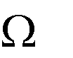**Table 9: Absolute maximum ratings**

#### cuation_b2 GPS receivers are Electrostatic Sensitive Devices (ESD) and require special precautions when handling. For more information see chapter [6.4.](#_bookmark63)

#### cuation_b2 Stressing the device beyond the “Absolute Maximum Ratings” may cause permanent damage. These are stress ratings only. The product is not protected against overvoltage or reversed voltages. If necessary, voltage spikes exceeding the power supply voltage specification, given in table above, must be limited to values within the specified boundaries by using appropriate protection diodes. For more information see the *LEA-6/ NEO-6/ MAX-6 Hardware Integration Manual* [[1].](#_bookmark73)

## Operating conditions

pointingfinger_b All specifications are at an ambient temperature of 25°C.

|  |  |  |  |  |  |  |  |
| --- | --- | --- | --- | --- | --- | --- | --- |
| **Parameter** | **Symbol** | **Module** | **Min** | **Typ** | **Max** | **Units** | **Condition** |
| Power supply voltage | VCC | NEO-6G | 1.75 | 1.8 | 1.95 | V |  |
|  |  | NEO-6Q/M NEO-6P/V/T | 2.7 | 3.0 | 3.6 | V |  |
| Supply voltage USB | VDDUSB | All | 3.0 | 3.3 | 3.6 | V |  |
| Backup battery voltage | V\_BCKP | All | 1.4 |  | 3.6 | V |  |
| Backup battery current | I\_BCKP | All |  | 22 |  | µA | V\_BCKP = 1.8 V, VCC = 0V |
| Input pin voltage range | Vin | All | 0 |  | VCC | V |  |
| Digital IO Pin Low level input voltage | Vil | All | 0 |  | 0.2\*VCC | V |  |
| Digital IO Pin High level input voltage | Vih | All | 0.7\*VCC |  | VCC | V |  |
| Digital IO Pin Low level output voltage | Vol | All |  |  | 0.4 | V | Iol=4mA |
| Digital IO Pin High level output voltage | Voh | All | VCC -0.4 |  |  | V | Ioh=4mA |
| USB\_DM, USB\_DP | VinU | All | Compatible with USB with 22 Ohms series resistance | | | | |
| VCC\_RF voltage | VCC\_RF | All |  | VCC-0.1 |  | V |  |
| VCC\_RF output current | ICC\_RF | All |  |  | 50 | mA |  |
| Antenna gain | Gant | All |  |  | 50 | dB |  |
| Receiver Chain Noise Figure | NFtot | All |  | 3.0 |  | dB |  |
| Operating temperature | Topr | All | -40 |  | 85 | °C |  |

**Table 10: Operating conditions**

pointingfinger_b Operation beyond the specified operating conditions can affect device reliability.

## Indicative power requirements

[Table 11](#_bookmark46) lists examples of the total system supply current for a possible application.

|  |  |  |  |  |  |  |  |
| --- | --- | --- | --- | --- | --- | --- | --- |
| **Parameter** | **Symbol** | **Module** | **Min** | **Typ** | **Max** | **Units** | **Condition** |
| Max. supply current 15 | Iccp | All |  |  | 67 | mA | VCC = 3.6 V16 /  1.95 V17 |
|  | Icc Acquisition | All |  | 4719 |  | mA |  |
|  | Icc Tracking  (Max Performance mode) | NEO-6G/Q/T |  | 4020 |  | mA |  |
|  | NEO-6M/P/V |  | 39[20](#_bookmark45) |  | mA |  |
| Average supply current18 | Icc Tracking  (Eco mode) | NEO-6G/Q/T |  | 38[20](#_bookmark45) |  | mA | VCC = 3.0 V[16](#_bookmark47) /  1.8 V[17](#_bookmark48) |
|  | NEO-6M/P/V |  | 37[20](#_bookmark45) |  | mA |  |
|  | Icc Tracking  (Power Save mode / 1 Hz) | NEO-6G/Q |  | 12[20](#_bookmark45) |  | mA |  |
|  | NEO-6M |  | 11[20](#_bookmark45) |  | mA |  |

**Table 11: Indicative power requirements**

pointingfinger_b Values in [Table 11](#_bookmark46) are provided for customer information only as an example of typical power requirements. Values are characterized on samples, actual power requirements can vary depending on FW version used, external circuitry, number of SVs tracked, signal strength, type of start as well as time, duration and conditions of test.

15 Use this figure to dimension maximum current capability of power supply. Measurement of this parameter with 1 Hz bandwidth.

16 NEO-6Q, NEO-6M, NEO-6P, NEO-6V, NEO-6T

17 NEO-6G

18 Use this figure to determine required battery capacity.

19 >8 SVs in view, CNo >40 dBHz, current average of 30 sec after cold start.

20 With strong signals, all orbits available. For Cold Starts typical 12 min after first fix. For Hot Starts typical 15 s after first fix.

## SPI timing diagrams

In order to avoid a faulty usage of the SPI, the user needs to comply with certain timing conditions. The following signals need to be considered for timing constraints:

|  |  |
| --- | --- |
| **Symbol** | **Description** |
| **SS\_N** | Slave Select signal |
| **SCK** | Slave Clock signal |

**Table 12: Symbol description**

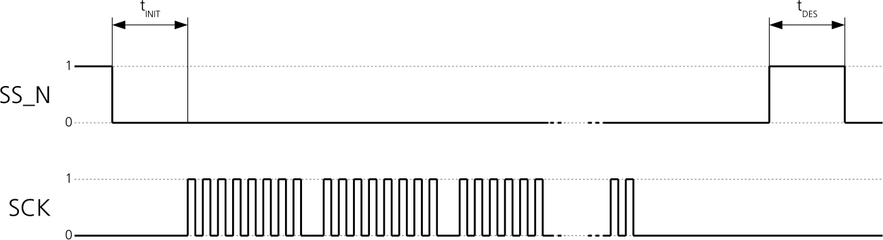

**Figure 3: SPI timing diagram**

### Timing recommendations

|  |  |  |
| --- | --- | --- |
| **Parameter** | **Description** | **Recommendation** |
| **tINIT** | Initialization Time | 500 s |
| **tDES** | Deselect Time | 1 ms |
| **Bitrate** |  | 100 kbit/s |

**Table 13: SPI timing recommendations**

pointingfinger_b The values in the above table result from the requirement of an error-free transmission. By allowing just a few errors, the byte rate could be increased considerably. These timings – and therefore the byte rate

– could also be improved by disabling other interfaces, e.g. the UART. pointingfinger_b The maximum bandwidth is 100 kbit/s21.

21 This is a theoretical maximum, the protocol overhead is not considered.

# Mechanical specifications

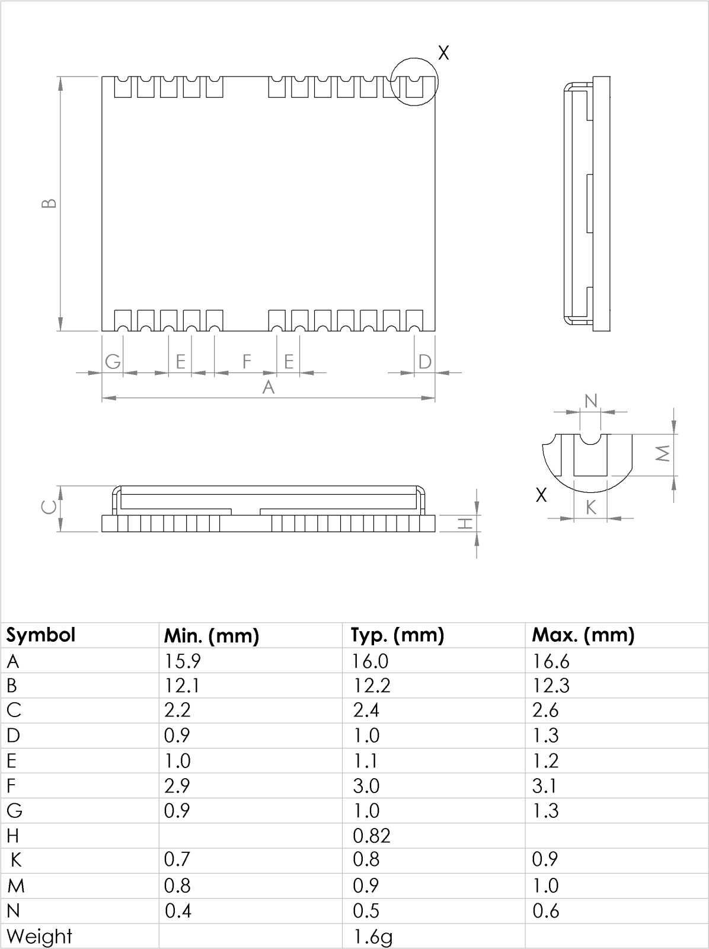

**Figure 4: Dimensions**

pointingfinger_b For information regarding the Paste Mask and Footprint see the *LEA-6/NEO-6/MAX-6 Hardware Integration Manual* [[1].](#_bookmark73)

# Qualification and certification

## Reliability tests

pointingfinger_b All NEO-6 modules are based on AEC-Q100 qualified GPS chips.

Tests for product family qualifications according to ISO 16750 "Road vehicles - Environmental conditions and testing for electrical and electronic equipment”, and appropriate standards.

## Approvals

Products marked with this lead-free symbol on the product label comply with the "Directive 2002/95/EC of the European Parliament and the Council on the Restriction of Use of certain Hazardous Substances in Electrical and Electronic Equipment" (RoHS).

All u-blox 6 GPS modules are RoHS compliant.

# Product handling & soldering

## Packaging

NEO-6 modules are delivered as hermetically sealed, reeled tapes in order to enable efficient production, production lot set-up and tear-down. For more information about packaging, see the *u-blox Package Information Guide* [[4].](#_bookmark76)

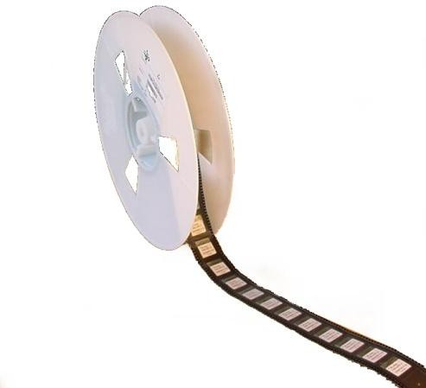

**Figure 5: Reeled u-blox 6 modules**

### Reels

NEO-6 GPS modules are deliverable in quantities of 250pcs on a reel. NEO-6 modules are delivered using reel Type B as described in the *u-blox Package Information Guide* [[4].](#_bookmark76)

|  |  |
| --- | --- |
| **Parameter** | **Specification** |
| Reel Type | B |
| Delivery Quantity | 250 |

**Table 14: Reel information for NEO-6 modules**

### 6.1.1 Tapes

[Figure 6](#_bookmark59) shows the position and orientation of NEO-6 modules as they are delivered on tape. The dimensions of the tapes are specified in [Figure 7.](#_bookmark60)

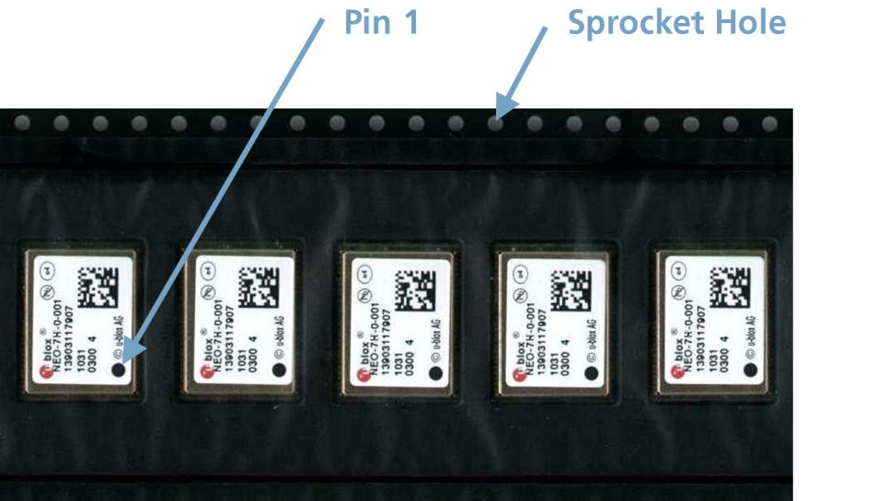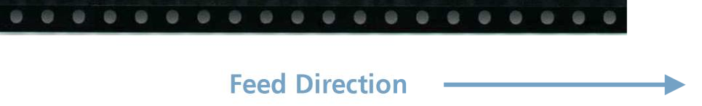

**Figure 6: Orientation for NEO-6 modules on tape**

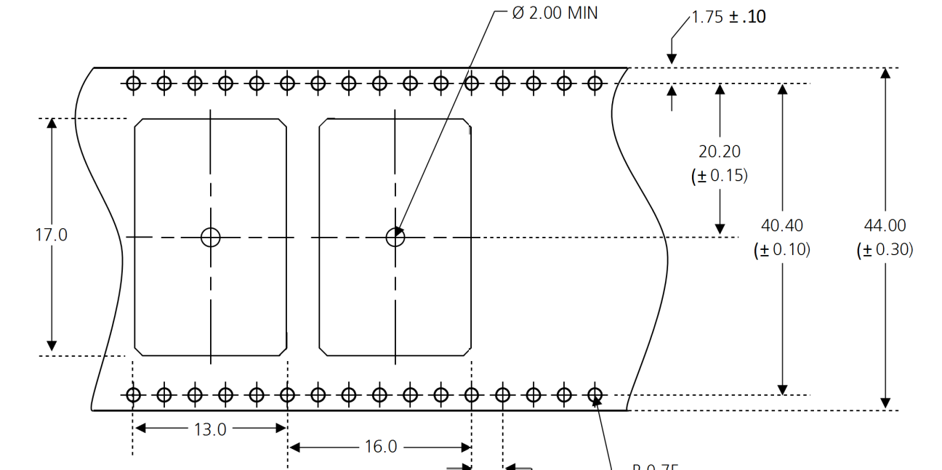

**Figure 7: NEO tape dimensions (mm)**

## Moisture Sensitivity Levels

#### cuation_b2 NEO-6 modules are Moisture Sensitive Devices (MSD) in accordance to the IPC/JEDEC specification.

NEO-6 modules are rated at MSL level 4. For more information regarding moisture sensitivity levels, labeling, storage and drying see the *u-blox Package Information Guide* [[4].](#_bookmark76)

pointingfinger_b For MSL standard see IPC/JEDEC J-STD-020, which can be downloaded from [www.jedec.org.](http://www.jedec.org/)

## Reflow soldering

Reflow profiles are to be selected according to u-blox recommendations (see *LEA-6/NEO-6/MAX-6 Hardware Integration Manual* [[1])](#_bookmark73).

## ESD handling precautions

#### eSD_Symbolcuation_b2 NEO-6 modules contain highly sensitive electronic circuitry and are Electrostatic Sensitive Devices (ESD). Observe precautions for handling! Failure to observe these precautions can result in severe damage to the GPS receiver!

GPS receivers are Electrostatic Sensitive Devices (ESD) and require special precautions when handling. Particular care must be exercised when handling patch antennas, due to the risk of electrostatic charges. In addition to standard ESD safety practices, the following measures should be taken into account whenever handling the receiver:

|  |  |
| --- | --- |
| Unless there is a galvanic coupling between the local GND (i.e. the work table) and the PCB GND, then the first point of contact when handling the PCB must always be between the local GND and PCB GND.  Before mounting an antenna patch, connect ground of the device |  |
| When handling the RF pin, do not come into contact with any charged capacitors and be careful when contacting materials that can develop charges (e.g. patch antenna ~10pF, coax cable ~50- 80pF/m, soldering iron, …) |  |
| To prevent electrostatic discharge through the RF input, do not touch any exposed antenna area. If there is any risk that such exposed antenna area is touched in non ESD protected work area, implement proper ESD protection measures in the design. |  |
| When soldering RF connectors and patch antennas to the receiver’s RF pin, make sure to use an ESD safe soldering iron (tip). |  |

# Default settings

|  |  |
| --- | --- |
| **Interface** | **Settings** |
| Serial Port 1 Output | 9600 Baud, 8 bits, no parity bit, 1 stop bit  Configured to transmit both NMEA and UBX protocols, but only following NMEA and no UBX messages have been activated at start-up:  **GGA, GLL, GSA, GSV, RMC, VTG, TXT**  (In addition to the 6 standard NMEA messages the NEO-6T includes **ZDA**). |
| USB Output | Configured to transmit both NMEA and UBX protocols, but only following NMEA and no UBX messages have been activated at start-up:  **GGA, GLL, GSA, GSV, RMC, VTG, TXT**  (In addition to the 6 standard NMEA messages the NEO-6T includes **ZDA**). USB Power Mode: Bus-Powered |
| Serial Port 1 Input | 9600 Baud, 8 bits, no parity bit, 1 stop bit  Automatically accepts following protocols without need of explicit configuration:  **UBX, NMEA**  The GPS receiver supports interleaved UBX and NMEA messages. |
| USB Input | Automatically accepts following protocols without need of explicit configuration:  **UBX, NMEA**  The GPS receiver supports interleaved UBX and NMEA messages. USB Power Mode: Bus-Powered |
| TIMEPULSE  (1Hz Nav) | 1 pulse per second, synchronized at rising edge, pulse length 100ms |
| Power Mode | Maximum Performance mode |
| AssistNow Autonomous | Disabled. |

**Table 15: Default settings**

Refer to the *u-blox 6 Receiver Description including Protocol Specification* [[2]](#_bookmark74) for information about further settings.

# Labeling and ordering information

## Product labeling

The labeling of u-blox 6 GPS modules includes important product information. The location of the product type number is shown in [Figure 8.](#_bookmark67)

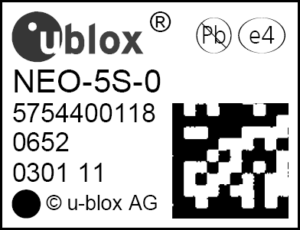

**PPP-GV-T-XXX**

#### Product type number

**Figure 8: Location of product type number on u-blox 6 module label**

## Explanation of codes

3 different product code formats are used. The **Product Name** is used in documentation such as this data sheet and identifies all u-blox 6 products, independent of packaging and quality grade. The **Ordering Code** includes options and quality, while the **Type Number** includes the hardware and firmware versions. [Table 16](#_bookmark69) below details these 3 different formats:

|  |  |
| --- | --- |
| **Format** | **Structure** |
| **Product Name** | PPP-GV |
| **Ordering Code** | PPP-GV-T |
| **Type Number** | PPP-GV-T-XXX |

**Table 16: Product Code Formats**

The parts of the product code are explained in [Table 17.](#_bookmark70)

|  |  |  |
| --- | --- | --- |
| **Code** | **Meaning** | **Example** |
| PPP | Product Family | NEO |
| G | Product Generation | 6 = u-blox6 |
| V | Variant | T = Timing, R = DR, etc. |
| T | Option / Quality Grade | Describes standardized functional element or quality grade such as Flash size, automotive grade etc. |
| XXX | Product Detail | Describes product details or options such as hard- and software revision, cable length, etc. |

**Table 17: part identification code**

## Ordering information

|  |  |
| --- | --- |
| **Ordering No.** | **Product** |
| NEO-6G-0 | u-blox 6 GPS Module, 1.8V, TCXO, 12x16mm, 250 pcs/reel |
| NEO-6M-0 | u-blox 6 GPS Module, 12x16mm, 250 pcs/reel |
| NEO-6Q-0 | u-blox 6 GPS Module, TCXO, 12x16mm, 250 pcs/reel |
| NEO-6P-0 | u-blox 6 GPS Module, PPP, 12x16mm, 250 pcs/reel |
| NEO-6V-0 | u-blox 6 GPS Module, Dead Reckoning SW sensor, 12x16mm, 250 pcs/reel |
| NEO-6T-0 | u-blox 6 GPS Module, Precision Timing, TCXO, 12x16mm, 250 pcs/reel |

**Table 18: Product Ordering Codes**

pointingfinger_bProduct changes affecting form, fit or function are documented by u-blox. For a list of Product Change Notifications (PCNs) see our website at: <http://www.u-blox.com/en/notifications.html>

# Related documents

1. LEA-6/NEO-6/MAX-6 Hardware Integration Manual, Docu. GPS.G6-HW-09007
2. u-blox 6 Receiver Description Including Protocol Specification (Public version),

Docu. No. GPS.G6-SW-10018

1. u-blox 6 Receiver Description Including Protocol Specification (Confidential version),

Docu. No. GPS.G6-SW-10019

1. u-blox Package Information Guide, Docu. No GPS-X-11004

pointingfinger_b For regular updates to u-blox documentation and to receive product change notifications please register on our homepage.

# Revision history

|  |  |  |  |
| --- | --- | --- | --- |
| **Revision** | **Date** | **Name** | **Status / Comments** |
|  | 31/08/2009 | tgri | Initial Version |
| 1 | 21/09/2009 | tgri | update of section 1.3 GPS performance, section 1.4 block diagram, section 3.2 peak supply current |
| A | 25/02/2010 | tgri | Change of status to Advance Information. Addition of NEO-6G. Update of section 1.8.2, removed reference to Vddio – added USB driver certification. Update of section 3.2 table 11: average supply current, Added section 3.3-3.4: SPI & DDC timing, section 5.1:  addition of table 12. |
| B | 24/06/2010 | dhur | Change of status to Preliminary. Update of section 1.2, 1.8.4, 1.10.4, 3.1, 3.2 and chapter 2 and 4. General clean-up and consistency check. |
| B1 | 11/08/2010 | dhur | Replaced graphic in figure 2. |
| C | 18/07/2011 | dhur | Added chapter 1.6, update to FW7.03. |
| D | 19/10/2011 | dhur | Added NEO-6P and NEO-6V.  Added chapter 1.7 and 1.8. Revised Chapter 6. |
| E | 05/12/2011 | dhur | Added NEO-6T.  Added chapter [1.7](#_bookmark14) and [1.8.](#_bookmark19)  Added Accuracy for Timepulse signal in [Table 2.](#_bookmark10)  Corrected Maximum Input power at RF\_IN for NEO-6P in [Table 9.](#_bookmark42) |

# Contact

For complete contact information visit us at [www.u-blox.com](http://www.u-blox.com/)

|  |  |  |
| --- | --- | --- |
| **Headquarters** |  |  |
| **u-blox AG**  Zuercherstrasse 68 CH-8800 Thalwil Switzerland  Phone: +41 44 722 74 44  Fax: +41 44 722 74 47  E-mail: [info@u-blox.com](mailto:info@u-blox.com) |  |  |
| **Offices** |  |  |
| **North, Central and South America** | **Europe, Middle East, Africa** | **Asia, Australia, Pacific** |
| **u-blox America, Inc.** | **u-blox AG** | **u-blox Singapore Pte. Ltd.** |
| Phone: +1 (703) 483 3180  E-mail: [info\_us@u-blox.com](mailto:info_us@u-blox.com)  **Regional Office West Coast:** | Phone: +41 44 722 74 44  E-mail: [info@u-blox.com](mailto:info@u-blox.com)  **Technical Support:** | Phone: +65 6734 3811  E-mail: [info\_ap@u-blox.com](mailto:info_ap@u-blox.com) Support: [support\_ap@u-blox.com](mailto:support_ap@u-blox.com) |
| Phone: +1 (703) 483 3184  E-mail: [info\_us@u-blox.com](mailto:info_us@u-blox.com)  **Technical Support:** | Phone: +41 44 722 74 44  E-mail: [info@u-blox.com](mailto:info@u-blox.com) | **Regional Office China:**  Phone: +86 10 68 133 545  E-mail: [info\_cn@u-blox.com](mailto:info_cn@u-blox.com) Support: [support\_cn@u-blox.com](mailto:support_cn@u-blox.com) |
| Phone: +1 (703) 483 3185  E-mail: [support\_us@u-blox.com](mailto:support_us@u-blox.com) |  | **Regional Office Japan:**  Phone: +81 3 5775 3850  E-mail: [info\_jp@u-blox.com](mailto:info_jp@u-blox.com) Support: [support\_jp@u-blox.com](mailto:support_jp@u-blox.com) |
|  |  | **Regional Office Korea:** |
|  |  | Phone: +82 2 542 0861  E-mail: [info\_kr@u-blox.com](mailto:info_kr@u-blox.com) Support: [support\_kr@u-blox.com](mailto:support_kr@u-blox.com) |
|  |  | **Regional Office Taiwan:** |
|  |  | Phone: +886 2 2657 1090  E-mail: [info\_tw@u-blox.com](mailto:info_tw@u-blox.com) Support: [support\_tw@u-blox.com](mailto:support_tw@u-blox.com) |